

**IT3060 Human Computer Interaction**

**3rd Year, 2nd Semester**

Assignment 2

**UX/UI for selcohr.com Website**

Submitted to

Sri Lanka Institute of Information Technology

|  |  |  |
| --- | --- | --- |
| **NAME** | **STUDENT ID** | **EMAIL** |
| P.T.N Fernando | IT20049140 | IT20049140@my.sliit.lk |
| P.A.D.S.D. Dilshan | IT20178154 | IT20178154@my.sliit.lk |
| B.M.G. Peiris | IT20147396 | IT20147396@my.sliit.lk |
| U.J.H Gunasinghe | IT20084318 | IT20084318@my.sliit.lk |
| K.G.S De Silva | IT20037192 | IT20037192@my.sliit.lk |

In partial fulfillment of the requirements for the

Bachelor of Science Special Honors Degree in Information Technology

**…..st Octorber 2022**

**Group No:** **2022-WE-S2-12**

**Content**

Table Of Content 2

Video Transcript 3

Usability Problems 6

Variants of the interfaces 7

Ideation techniques used 25

How the best design was selected 25

Time schedule (Gantt chart) 25

Appendix 26

References 35

# **Video Transcript**

**Manager**

**Interviewer**: **Good evening.My name is Malshika Peiris and I am one of the member of this selcohr company.so nice to meet you!** [00:00:03]

Manager: Thank you Malshika. I am Hivindu Punsith.It’s nice to meet you! [00:00:06]

**Interviewer**: **How are you doing Hivindu?** [00:00:09]

Manager: yes ,I am fine. [00:00:012]

Interviewer: **Okay Hivindu,today I will take your interview.so let’s get started now.** [00:00:016]

Manager: yea,sure [00:00:018]

**Interviewer**: **In the very first I warmly Welcome to selcohr company.You know Selcohr Continental Pvt. Ltd.is an overseas placement company, duly licensed by the Sri Lanka Bureau of Foreign Employment, are geared to provide you an efficient personnel recruitment service that you would hate to miss. Our highly efficient and dedicated team of staff are constantly prepared to fulfill virtually all your human resource requirements.** [00:00:29]

Manager:Oh!great. [00:00:30]

**Interviewer: so are you fresher?** [00:00:33]

Manager: No ,actually I worked in We are designers company as a Manager.now I wanna know about what are the best job opportunities ,what are weakest aspects of job vacansis and of course I want to know how many job vacansis are left on this site as well. [00:00:37]

**Interviewer: nice . can I have some quesions from you?** [00:00:45]

Manager: sure here you go. [00:00:55]

**Interviewer: okay hivindu,Now tell me about yourself**. [00:01:05]

Manager: I went to university of SLIIT of Malabe,SriLanka and majored in Software Engineering.I started my career at a WireApps software development company.Now I working in a progressive company with more creative members as a Manager and it is “We are designers”. [00:01:35]

**Interviewer** : **Oh! Great . Have you used any website like this before to start your business?** [00:01:40]

Manager: yea! Actually I have used some web sites before because of this site has so many problems.I couldn’t gain my task that I wanted due to this site as well. [00:01:55]

**Interviewer: Oh! Really ,can you tell me how did you come to know about this website?** [00:02:15]

Manager: yea,one day I had wanna find some job opportunities and I searched what are job vacancy web sites in the google.that was the way that I know about this website. [00:02:35]

**Interviewer: Do you think this website will be useful for your start up?** [00:02:45]

Manager:Definitely no.It has too issues .Accually I can’t find what are job categories cleary.That website is not user friendly and not user attractive. [00:03:00]

**Interviewer:yea ,I can understand so Is it easier to use this website?** [00:03:15]

Manager: maybe it is easy , I mean not difficult but everyone can’t enter this website easily. [00:03:25]

**Interviewer: ok ! hivindu, Can you show us how to log in to this web site .** [00:03:27]

Manager:ok sure. [00:03:35]

**Interviewer:ok,How do you find job vacancy for an Accountant Assistance.** [00:03:40]

Manager:ok sure. [00:03:50]

**Interviewer: thank you hivindu ,Please Can you show me the job vacancy for an IT Manager?** [00:03:55]

Manager:ok sure. [00:04:05]

**Interviewer: Hivindu,Can you show us how to log out from this web site ?** . [00:04:09]

Manager:ok sure. . [00:04:12]

**Interviewer:okay hivindu.interview done.Do you have any questions for me?** . [00:04:13]

Manager: No ,I think I have a pretty good understanding of this interview. . [00:04:22]

**Interviewer: yea .nice to meet you hivindu.Thank you for coming.** . [00:04:23]

Manager: nice meeting you too and thank you so much. . [00:04:29]

**Job Seeker**

**Interviewer:**  **hello, good evening Kushan. I’m sachin.** [00:00:04]

Job Seeker: Good evening[00:00:06]

**Interviewer:**  **how are you doing today Kushan?** [00:00:08]

Job Seeker: I’m doing well and I’m fine[00:00:13]

**Interviewer: Kushan, could you please give me a introduction about yourself?** [00:0:16]

Job Seeker:  I’m Kushan Dimantha. I had completed my internship at nextmatrixlab. It’s an IT company that design web applications and mobile application. So now I’m looking for new job opportunities in the industry and therefor I always tends to use this website to search new jobs and maintain my online CV**.** [00:00:20]

**Interviewer:**  **okey. looks like you have good experience about the website. Can you please login to the site by using job seeker login**[00:00:56]

Job Seeker:  okey give me a second(go to login page) [00:01:09]

**Interviewer:**  **Kushan, what do you think about this login page?** [00:01:26]

Job Seeker: I think the colors are okey. but the user friendliness is not there. The login page should be in the center of the webpage and the font size should be maximize. And I also I didn’t like where the register button is located**.** [00:01:30]

**Interviewer:**  **okey Kushan. Now please login as job seeker and go to home page. And tell me what you think about the interface?** [00:01:56]

Job Seeker: Yeah, sure. Okey this is the job seeker homepage. I feel like it’s so messy an large part of page looks empty. the description given in the page is not related to my personal profile[00:02:03]

**Interviewer: okey Kushan. Please tell me what are the expected things to be changed in this interface**[00:02:34].

Job Seeker:  first thing is the logout button. It’s difficult to find the logout button. It’s gives a bad user experience and there is a popup saying click to built your resume. It should be changed and also the three forms and form color should be changed to light color than the page background color. [00:02:38]

**Interviewer:**  **what about the table in the bottom of the site? [00:03:18]**

Job Seeker: it’s looks okey to me. inside of the data table should be lighter than the web page. And also the footer must be changed in attractive way. [00:03:27]

**Interviewer: okey Kushan. Can you please click that click to built button and tell me some thing about the interface.** [00:03:43]

Job Seeker:  the form color look good to me. but the text fields and filling fields are not aligned correctly. for the preferred countries field it’s better to use dropdown list. And the save button should be bit large. It’s difficult to read the content inside button. [00:03:54]

**Interviewer:**  **okey Kushan. The interview is done. I had very good informative session with you. Your information would be very important to us.** [00:04:24]

Job Seeker: thanks for giving me this chance. there is lot of areas in this website that can be developed. In my opinion this is a important website for job seekers. The functions are really good. The only problem is the user interfaces. I think my answers will help to you as developer. [00:04:36]

**Interviewer: yes, it’s a great help for us too. Thank you for joining today Kushan.** [00:05:00]

Job Seeker: Thank you**.** [00:05:06]

# **Usability Problems**

* Unnecessary Listing Location link .
* Header and footer on the website do not match.
* Use of inappropriate colors.
* Font size is too small.
* There are more white spaces.
* Added unnecessary features.
* Some functions will not be helping and there are not working.
* Forms should be more improve.
* Products contained in this website have added a watermark without any management.
* Warning messages and notices are not user friendly.
* Unnecessary text field available.
* Placeholders are missing.
* The logo used does not have any quality.
* Some Page titles are missing.
* Difficult to find some details.

**Variance of the interfaces**

IT number – IT20178154

Interface name – Career Resource

**In the both version 1 & 2 I include the same header, footer and navigation bar.**

|  |  |
| --- | --- |
| Career Resource(Version 1) | Career Resource (Version 2) |
| PROS :   * more user friendly. * Structure is very clear to user. * User can find their jobs by directly typing on the searching bar. * Placements of the contents are good * Reduce empty space. * There are small three ads space at the left side of the page, and it could attract the Users | PROS :   * From the searching bar customers can searching the items what they are looking for. * Paragraphs can be identifying easy. * User can read the content of paragraph easy. |
| CONS :   * The icons and the advertisements on the page are in small letters and the home page looks like very crowded | CONS :   * Letters are too small to read * There is no any place to take instructions or any help center with answer for common questions which can arise in customers while they are using this. * There are big add spaces. * Not more attractive |
| JUSTIFICATIONS :   * In this (Version 01) Career Resource page although it has some cons, due to the creativity of that About us page, it can get the attention of the customer. * And there are many items has shown in the first page and no need to go one by one. It will save the time of the user. In this page although the designer has tried to make it in a user-friendly manner it will take more time and the busy customers may not like it. * According to these facts the first one will be most user-friendly Career Resource page for the User * Therefore, I choose the (version 01) on as the most suitable one. | |

Interface name – Employee Home

**In the both version 1 & 2 I include the same header, footer and navigation bar.**

|  |  |
| --- | --- |
| Employee Home (Version 1) | Employee Home (Version 2) |
| PROS :   * more user friendly. * Structure is very clear to user. * User can find and view there resume details here and clear photo of them * User can easily find and apply for jobs from table view * Reduce empty space. * There are clear buttons for go to the resume update and guideline pages | PROS :   * User can also change their password * User can easily find and apply for jobs from table view |
| CONS :   * Page look bit crowded | CONS :   * Too much functions in one page * There is no any place to take instructions or any help center with answer for common questions which can arise in customers while they are using this. * There are big add spaces. |
| JUSTIFICATIONS :   * In this (Version 01) Employee Home page although it has some cons, due to the creativity of that Employee Home page, it can get the attention of the customer. * And there are many items has shown in the first page and no need to go one by one. It will save the time of the user. In this page although the designer has tried to make it in a user-friendly manner it will take more time and the busy customers may not like it. * According to these facts the first one will be most user-friendly Employee Home page for the User * Therefore, I choose the (version 01) on as the most suitable one. | |

Interface name – Employee Profile

**In the both version 1 & 2 I include the same header, footer and navigation bar.**

|  |  |
| --- | --- |
| Employee Profile (Version 1) | Employee Profile (Version 2) |
| PROS :   * more user friendly. * Structure is very clear to user. * User can find and view there resume details here and clear photo of them * User can easily fill the form because added some drop down lists for text fields * Reduce empty space. * There are clear buttons for submissions | PROS :   * User can manually fill details * User can simply find new jobs using the adds section from bottom of the table |
| CONS :   * Page look bit crowded | CONS :   * Form is too much complex * There is no any place to take instructions or any help center with answer for common questions which can arise in customers while they are using this. * There are big add spaces. |
| JUSTIFICATIONS :   * In this (Version 01) Employee Profile page although it has some cons, due to the creativity of that Employee Profile page, it can get the attention of the customer. * And there are many items has shown in the first page and no need to go one by one. It will save the time of the user. In this page although the designer has tried to make it in a user-friendly manner it will take more time and the busy customers may not like it. * According to these facts the first one will be most user-friendly Employee Home page for the User. In this page although the designer has tried to make it in a user-friendly manner it will take more time and the busy customers may not like it. Because must go by selecting one by one. * Therefore, I choose the (version 01) on as the most suitable one. | |

IT number – IT20147396

Interface name – About Us

**In the both version 1 & 2 I include the same header, footer and navigation bar.**

|  |  |
| --- | --- |
| About Us (Version 01 ) | About Us (Version 02 ) |
| PROS :   * more user friendly. * Structure is very clear to user. * More User attractive. * Placements of the contents are good * Reduce empty space. * Paragraphs can be identifying easy. User can read the content of paragraph easy. * Structure was good comparing the original UI. * Has good color combination. | PROS :   * Content separating is good. * Paragraphs can be identifying easy. * User can read the content of paragraph easy. |
| CONS :   * Some letters may small * It has pictures and user may not get clear idea about that short imagers. | CONS :   * It is too normal and background color is not matching with button colors. * Button colors are not suitable. * There is no place to find instructions for the first-time users. * Image size is not proper. * Not more attractive |
| JUSTIFICATIONS :   * In this (Version 01) About us page although it has some cons, due to the creativity of that About us page, it can get the attention of the customer. * In this page although the designer has tried to make it in a user-friendly manner it will take more time and the busy customers may not like it. Because must go by selecting one by one. * According to these facts the first one will be most user-friendly home page for the customer, because through it they can go quickly for their searching sites, and it will save their time. * Therefore, I choose the (version 01) on as the most suitable one. | |

IT number – IT20147396

Interface name – Vacancy Page

**In the both version 1 & 2 I include the same header, footer and navigation bar.**

|  |  |
| --- | --- |
| Vacancy Page (Version 01 ) | Vacancy Page (Version 02 ) |
| PROS :   * Has good color combination (pink and blue) * Easy to understand * User attractive * Reduce messy content and separate the paragraphs with topic. * Structure was good comparing the original UI. * Reduce empty space * Reducing a complexity for new uses * Button colors and background color is best. | PROS :   * Reducing a complexity for new uses * Button colors are good * Font size is good * Using light background colors |
| CONS :   * Using some different shapes. | CONS :   * Not balancing * Button colors and background colors are not matching * Using so many different symbols * User can’t get better understand of this symbols * Sometime background color is not proper.it has some dark colors. * Using some different shapes. * Sometime background color is not proper.it has some dark colors. |
| JUSTIFICATIONS :   * Compared to the second UI, I will choose the (Version 01 ). The reason to select the first UI is it well organized. The filtration if data is clear and sort by is shown. User can navigate to them easily. Where in second one these features are not available at one glance.it can get the attention of the customer. In this page although the designer has tried to make it in a user-friendly manner it will take more time and the busy customers may not like it. Because must go by selecting one by one. * According to these facts the first one will be most user-friendly home page for the customer, because through it they can go quickly for their searching sites, and it will save their time. Therefore, I choose the (version 01) on as the most suitable one. | |

IT number – IT20147396

Interface name – User Profile Page

**In the both version 1 & 2 I include the same header, footer and navigation bar.**

|  |  |
| --- | --- |
| User Profile Page (Version 01 ) | User Profile Page (Version 02 ) |
| PROS :   * Has a great color palette (blue and white). * Users can easily understand the structure. * More appealing to users. * The contents are positioned well. * Made less empty space. * It is simple to recognize paragraphs. The user can easily read the paragraph's content. * In contrast to the another UI, the structure was best. * Has a nice color scheme. | PROS :   * It is wise to separate the content. * It is simple to recognize paragraphs. * The user can easily read the paragraph's content. |
| CONS :   * It features photos and some of the letters may be small, making it difficult for the user to understand the short images. | CONS :   * It is overly conventional and the button colors don't match the backdrop color. * Button colors are inappropriate. * There is nowhere for novice users to find instructions. * The image size is incorrect. * Not more alluring |
| JUSTIFICATIONS :   * In this (Version 01) User Profile Page although it has some categories (I divided entire form into few sub categories because of ease of use ) and I thing version 1 interface is very understanding than the version 2 interface. * These data indicate that the first one will be the most user-friendly home page for the client because it allows them to rapidly access their search sites while saving them time. As a result, I decide that (version 01) is the best option. | |

# **Ideation techniques used**

Ideation technique is a creative process of generating new ideas that can be realized through a variety of Ideation technique, such as for example brainstorming, Mind Mapping , SCAMPER, and Brainwriting.

In here We have used below techniques.

* Brainstorming

Brainstorming is one of the ideation techniques that we use when designing the interfaces.it was helpful for us in engaging as a group to discuss and analyze the issues with website that we chose through collective thinking and listening to ideas of our group members we designed the best and most visual appealing interface for each of our pages on the website .

* Worst Possible Idea

This was the best technique to identify weaknesses in our interfaces. All members had some kind of idea which would be terrible to implement. This technique helped us to identify them early on and paved the way to design user friendly interfaces.

* Brainwriting

We communicate regularly through online meetings and then document our ideas.

* Sketching
* Prototyping
* Mind mapping
* Paper Interface

# **How the best design was selected**

**IT Number – IT20178154**

**Interface Name – Career Resource**

* To foster a superior connection point for my page, I used ideation strategies, for example, mind composing, conceptualizing, portraying, and prototyping. Mind composing was the principal approach I utilized as an ideation procedure.
* To start with, First, I observed my page and identified the ways of redesigning the page. Then I wrote down my ideas and arranged them.
* From that point forward, I introduced my plans to the gathering individuals and requested their criticism (Conceptualizing).
* Then, I get their general thoughts and change my page and bring it into the paper (Paper interfaces).
* I utilized draw.io to portray the connection points in the wake of concluding the thoughts (Outlining).
* Then, at that point, we had a gathering discussion to go through our points of interaction and check whether there was whatever we might do to make them more easy to understand (Conceptualizing).
* Then once again, we had discussions to find out if we can optimize our interfaces more (Brainstorming). Then we finalized on one interface, which is version one interface

**Interface Name – Employee Home**

* To develop a better interface for my page, I utilized ideation techniques such as brain writing, brainstorming, sketching, and prototyping. Brain writing was the first approach I used as an ideation technique.
* I have used ideation techniques like brain writing, brainstorming, sketching, and prototyping to design a better interface for my page. First ideation technique I used is brain writing
* Understanding that, I introduced my considerations to the individuals from the gathering and mentioned their criticism (Conceptualizing).
* I examined my page to identify prospective makeover possibilities. Then I noted down and arranged my thoughts.
* In the wake of finishing the ideas, I utilized draw.io to portray the connection points (Outlining).
* Then we had a gathering conversation to glance through our points of interaction and see how we could make them easier to understand (Conceptualizing).
* Subsequent to considering the upsides and downsides and ideation methods, I concluded that version 1 was the most ideal rendition for this connection point.

**Interface Name – Employee Profile**

* Claims Support The first approach I explored for ideation technique was brain writing. First, I looked through my page to see if there were any potential makeovers.
* Then I scribbled and organized my thoughts.
* Following that, I presented my ideas to the group members and solicited their comments (Brainstorming).
* Following that, I take their general suggestions and modify my page to include them into the paper (Paper interfaces).
* I used draw.io to sketch the interfaces once I finished the concepts (Sketching). Then we had a group conversation to go through our interfaces and see what we might do to improve them (Brainstorming).
* We settled on the final interfaces after additional discussions and drawing and chose version 1 as the final interface.
* After considering the pros and cons as well as brainstorming approaches, I determined that version 1 was the ideal version for this interface.

**IT Number – IT20147396**

**Interface Name – About US**

* To foster a superior connection point for my page, I used ideation strategies, for example, mind composing, conceptualizing, portraying, and prototyping. Mind composing was the principal approach I utilized as an ideation procedure.
* To start with, I concentrated on my page and distinguished potential makeover choices. Then, at that point, I noted down my viewpoints and coordinated them.
* From that point forward, I introduced my plans to the gathering individuals and requested their criticism (Conceptualizing).
* Then, I get their general thoughts and change my page and bring it into the paper (Paper interfaces).
* I utilized draw.io to portray the connection points in the wake of concluding the thoughts (Outlining).
* Then, at that point, we had a gathering discussion to go through our points of interaction and check whether there was whatever we might do to make them more easy to understand (Conceptualizing).
* We settled on the last points of interaction and picked version 1 as the last point of interaction after extra conversation and drawing.
* Subsequent to considering the advantages and disadvantages and ideation procedures, I established that version 1 was the best adaptation for this connection point.

**Interface Name – Vacancy Page**

* Demand a pressing of same Day Conveyance As an ideation strategy, the main way I attempted was cerebrum composing.
* In the first place, I analyzed my page to distinguish planned makeover prospects. Then I wrote down and organized my considerations.
* Understanding that, I introduced my considerations to the individuals from the gathering and mentioned their criticism (Conceptualizing).
* Following that, I take their wide thoughts and change my page and get it into the paper (Paper interfaces).
* In the wake of finishing the ideas, I utilized draw.io to portray the connection points (Outlining).
* Then we had a gathering conversation to glance through our points of interaction and see how we could make them easier to understand (Conceptualizing).
* Subsequent to considering the upsides and downsides and ideation methods, I concluded that version 1 was the most ideal rendition for this connection point.

**Interface Name – User Profile**

* Claims Support The first approach I explored for ideation technique was brain writing. First, I looked through my page to see if there were any potential makeovers.
* Then I scribbled and organized my thoughts.
* Following that, I presented my ideas to the group members and solicited their comments (Brainstorming).
* Following that, I take their general suggestions and modify my page to include them into the paper (Paper interfaces).
* I used draw.io to sketch the interfaces once I finished the concepts (Sketching). Then we had a group conversation to go through our interfaces and see what we might do to improve them (Brainstorming).
* We settled on the final interfaces after additional discussions and drawing and chose version 1 as the final interface.
* After considering the pros and cons as well as brainstorming approaches, I determined that version 1 was the ideal version for this interface.

# **Time schedule (Gantt chart)**

# **Appendix**

**IT20178154 – Dilshan P.A.D.S.D**

selected Career Resource (version 1) Not selected Career Resource (version 2)

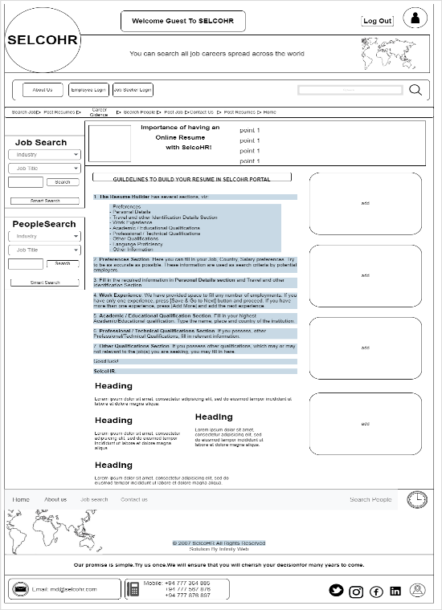

selected Employee Home Page (version 1) Not selected Employee home (version 2)

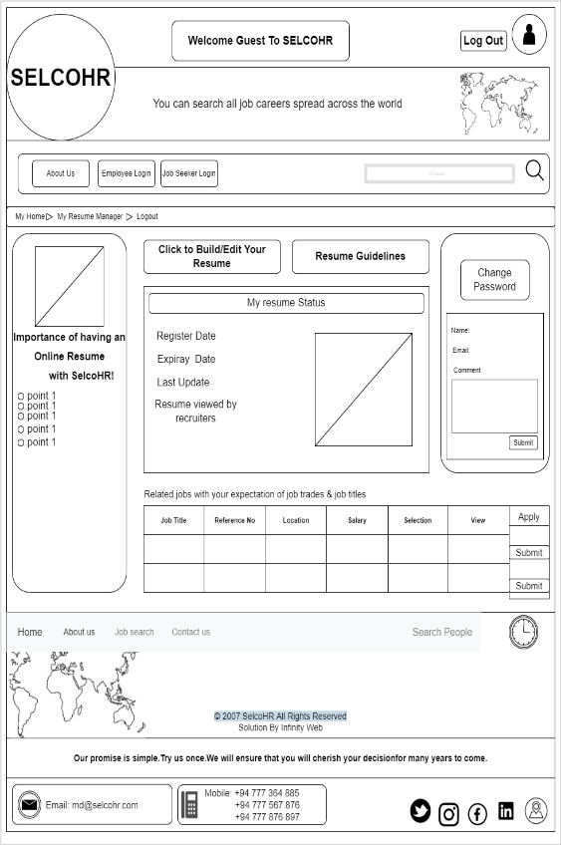 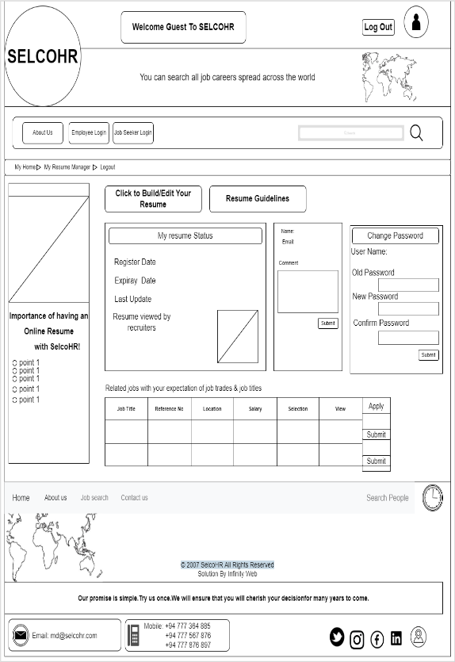

selected Employee Profile Page (version 1) Not selected Employee Page(version 2)

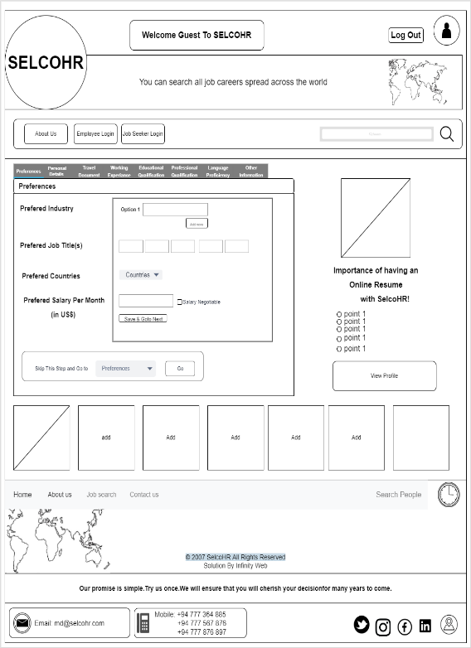

**IT20147396 – Peiris B.M.G**

Not selected Vacancy Page (version 2) selected Vacancy Page (version 1)

Selected profile (version 1)Not selected profile (version 2)

Selected About us (version 1) Not Selected About us (version 2)

# **References**

**Usability.gov**

[**https://www.usability.gov/what-and-why/user-interface-design.html**](https://www.usability.gov/what-and-why/user-interface-design.html)

**Future Learn**

[**https://www.futurelearn.com/info/blog/introduction-to-ux-ui**](https://www.futurelearn.com/info/blog/introduction-to-ux-ui)